EEE3088F 2023

Interim Design Report

Group 09 Light Sensor HAT

Ankush Chohan (CHHANK001)

Tinashe Timba (TMBTIN004)

Murray Inglis (INGMUR002)

23/04/2023

**1 Executive Summary**

The following report documents the design process and current design of a Light Sensor Discovery board HAT intended for use as a quality checker in glass manufacturing, water purification, and farming processes. Section 2 outlines these use cases in more detail along with the block system designed to meet the basic requirements. The schematic designs for the sub-modules can be found here…..

Technical specifications outlining the system requirements of the design and the related power consumption details are included in Section 3. An Agile process was followed to refine the project at each stage. Given the design, the device is capable of monitoring light intensity levels and managing the battery-powered system to ensure safety and long use.

For further details including licensing, reusing, and deploying; see the GitLab repository .

2 Introduction

The team has designed a digital light sensor that works in conjunction with the STM32 microcontroller. It can be used to detect and monitor light intensity throughout the day and this data can be stored externally and be analyzed for determining the light intensity conditions at the sensor’s location. The sensor can provide information such as the maximum and minimum light intensity experienced during the day. By placing the sensor at various conditions, the recorded data can be used to find the optimum location for a specific use.

The HAT will also have an analogue sensor that will measure the battery percentage of the device. This value can then be displayed on LEDs that are mounted on the board.

User role/Scenario1:

In a water purification plant, the water can be run through a glass tube with a light on one side and a light sensor on the other. Depending on the amount of light that passes through the water, the water quality can be gauged.

* A compact device that can be mounted on existing machinery.
* High accuracy reading to be generated for quality control purposes.
* Cost-effective solution. The cost of producing 5 of these boards is below USD70.

User role/Scenario2:

The device can be used to measure the quality of glass in a glass production line. Depending on the

value of light intensity that passes through a pane of glass, the glass can be categorized.

* User-friendly design that does not require technical training for employees.
* Robust design with low maintenance costs. The cost of producing 5 of these boards is below USD70.
* Takes readings at a fast rate to minimalize delays in production (5Hz).

User role/Scenario3

The device can be used by subsistence farmers to find the optimal position in their plot to grow specific varieties of plants depending on the lighting conditions that these plants thrive in. In this case the device will be placed out-doors therefore the onboard battery and battery level sensor will be useful.

* The device must be battery-powered as it will be placed outdoors far away from a power
* supply.
* Easy to move and set up.
* Efficient power consumption design switches certain modules into sleep mode when they are not being used.

2.1 Project Subsystems Block Diagram

3 Specifications

3.1 Power subsystem submodule

Charging module:

IC used: TP4054-42

* Voltage input: 5V
* Voltage output to battery: 4.1V
* Current input: 0.5A
* Overcharge protection: regulates up to 18V down to 5V

Power supply to HAT:

3v3 Regulator IC used: AMS1117-3_3

* Voltage input from battery (4.1V-1V)
* Voltage output: 3.235V – 3.365V
* Current: 27mA
* Overcharge protection: regulates up to 18V down to 3.3V
* Schottky diode polarity protection
* Under voltage protection (1V lockout)

Conclusion:

Simulations of the under-voltage lockout circuit have shown lockout at around 1V which is too low a value for the HAT to operate. Additionally, the lockout level of the circuit is dependent on the load. Therefore, this circuit cannot be relied on until a physical test is done. The design, however is still safe due to the inclusion of intentional redundancy in the design. The under-voltage lockout circuit can be bypassed.

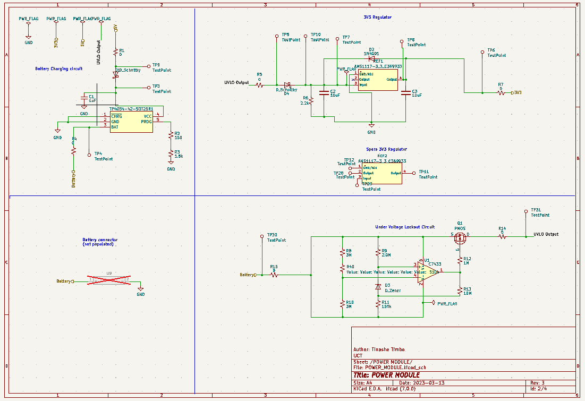 Figure 1: Power submodule

3.2 Microcontroller interfacing submodule

Micro-usb:

* Name: USB 2.0 Surface Mount Female Micro-B SMD
* Part number: C404969
* Current rating: 1.8A
* Voltage rating: 30V

EEPROM:

IC used: AT24C256C-SSHL-T EEPROM

* Part number: C6482
* Operating voltage: 1.7V – 5.5V
* Operating read current: 1mA
* Operating write current: 3mA

USB to UART convertor:

IC used: CP2102-GMR

* Part number: C6568
* Operating voltage: 3V-3.6V
* Supply current: 200uA

Conclusion:

The team is satisfied with this submodule and believes that it has good design. There are no outstanding issues.

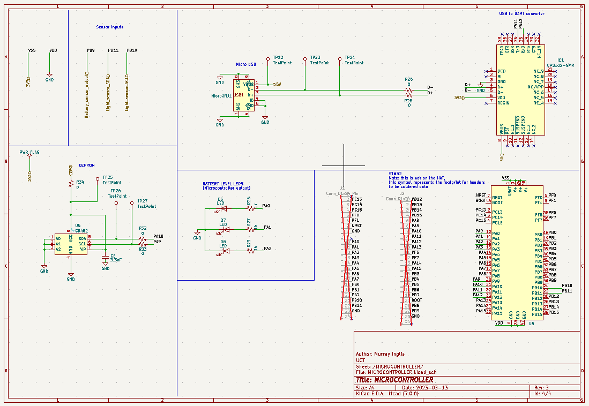

Figure : Microcontroller submodule

3.3 Sensing submodules

Digital optical sensor:

IC used: LTR-303ALS-01

* Supply voltage: 2.4V - 3.6V
* Interface bus supply voltage: 1.7V - 3.6V
* I2C Bus Input Pin High Voltage: 1.2V
* I2C Bus Input Pin Low Voltage: 0.6V
* Operating temperature: -30°C – 70°C
* Active supply current: 220uA
* Standby current: 5uA
* Initial startup time: 100ms
* Wakeup time from standby: 10ms

Analogue battery sensor:

* Input voltage from battery: 1V – 5V
* Output voltage: 0V - 2.5V
* Output current: 27mA

Conclusion:

The team is satisfied with this submodule and believes that it has good design. There are no outstanding issues.

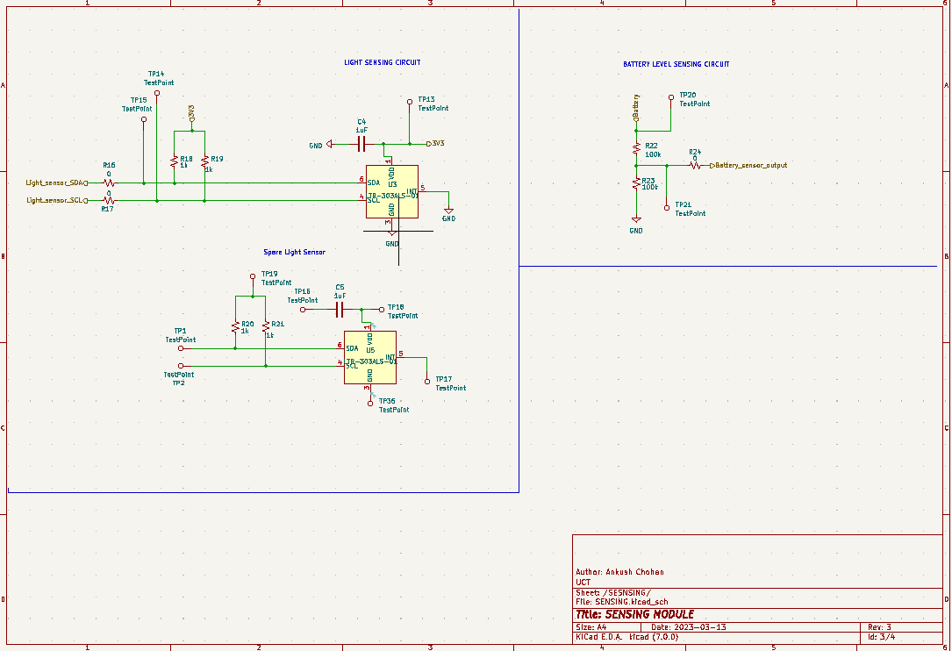

Figure 3: Sensing submodule

4 Power Budget Analysis

4.1 Power submodule

|  |  |  |  |  |  |  |  |
| --- | --- | --- | --- | --- | --- | --- | --- |
| **Component** | **Supply Voltage (nominal V)** | **Minimum Current (mA)** | **Typical Current (mA)** | **Maximum Current (mA)** | **Minimum Power (mW)** | **Typical Power (mW)** | **Maximum Power (mW)** |
| Battery charger (TP4054-42) | 5 | 0 | 0.150 | 0.500 | 0 | 0.75 | 2.5 |
| Voltage regulator (AMS1117-3_3) | 4.8 | 900 | 1100 | 1500 | 4.32 | 5.28 | 7.2 |
|  |  |  |  |  |  |  |  |
|  |  |  |  |  |  |  |  |
|  |  |  |  |  |  |  |  |
| **Totals** |  |  |  |  | 4.32 | 6.03 | 9.7 |

4.2 Microcontroller interfacing submodule

|  |  |  |  |  |  |  |  |
| --- | --- | --- | --- | --- | --- | --- | --- |
| **Component** | **Supply Voltage (nominal V)** | **Minimum Current (mA)** | **Typical Current (mA)** | **Maximum Current (mA)** | **Minimum Power (mW)** | **Typical Power (mW)** | **Maximum Power (mW)** |
| FTDI (CP2102-GMR) | 3.3 | 0 | 20 | 26 | 0 | 66 | 85.8 |
| EEPROM (AT24C256C) | 3.3 | 0 | 1 | 2 | 0 | 3.3 | 6.6 |
|  |  |  |  |  |  |  |  |
|  |  |  |  |  |  |  |  |
|  |  |  |  |  |  |  |  |
| **Totals** |  |  |  |  | 0 | 69.3 | 92.1 |

4.3 Sensing submodules

|  |  |  |  |  |  |  |  |
| --- | --- | --- | --- | --- | --- | --- | --- |
| **Component** | **Supply Voltage (nominal V)** | **Minimum Current (mA)** | **Typical Current (mA)** | **Maximum Current (mA)** | **Minimum Power (mW)** | **Typical Power (mW)** | **Maximum Power (mW)** |
| Light sensor (LTR-303ALS-01) | 3.3 | 0.005 | Not stated in datasheet | 0.22 | 0.165 | NA | 0.726 |
|  |  |  |  |  |  |  |  |
|  |  |  |  |  |  |  |  |
|  |  |  |  |  |  |  |  |
|  |  |  |  |  |  |  |  |
| **Totals** |  |  |  |  |  |  |  |

Caveats:

For the battery sensor, there is no IC being used but power will be drawn by the voltage divider used to create a voltage for the STM32 ADC.

Additionally, the typical current for the light sensor IC was not stated in the datasheet, so the typical power could not be found.

4.4 System total

|  |  |  |  |  |  |  |  |
| --- | --- | --- | --- | --- | --- | --- | --- |
| **Submodule** | **Supply Voltage (nominal V)** | **Minimum Current (mA)** | **Typical Current (mA)** | **Maximum Current (mA)** | **Minimum Power (mW)** | **Typical Power (mW)** | **Maximum Power (mW)** |
| PSU | 5 |  |  |  | 4.32 | 6.03 | 9.7 |
| Sensor 1 |  |  |  |  | 0.165 | NA | 0.726 |
| Sensor 2 |  |  |  |  |  |  |  |
| Memory |  |  |  |  | 0 | 3.3 | 6.6 |
| Microprocessor |  |  |  |  |  |  |  |
| **Totals** |  |  |  |  |  |  |  |

5 Design process

After brainstorming, the team settled on designing a HAT with a digital light sensor and an analogue battery level sensor. The decision was made due to the fact that the team believed this would be a simple and cost-effective approach to meet the basic requirements.

The team decided to use the LTR-303ALS-01 for the light sensor because it was one of the cheapest and had a large stock quantity. It also had clear application circuits.

The implementation of the battery level sensor was chosen to be a voltage divider to the STM32 ADC. This decision was made due to the implementation being simple and cheap.

The AT24C256C EEPROM was chosen because it was a basic part and had a large stock quantity.

The CP2102-GMR USB to UART converter (FTDI) chip was chosen because it was one of the cheapest USB to UART converters available on JLCPCB and it had a large stock quantity.

An inflection point the team encountered was that initially, the schematic included pin headers for the debugger, however after consultation with the tutor, it was decided that it would be simpler and more effective to just use jumper cables to the debugger on the discovery board.

A problem that was encountered by the team was that all traces for the PCB were placed on the top layer. This led to a lack of space and an untidy board layout. Setting the bottom layer to a ground plane simplified this process, as well as using vias and tracks on the bottom plane.

During the design process, the team decided to include spare components on the HAT for redundancy. Seeing as the budget allowed for this and warnings were received that components from JLCPCB could be faulty or missing entirely.

6 Conclusion

In conclusion, the design requirements stated that a PCB with capabilities to handle and process information for 2 sensors where addressed by designing a HAT with a digital light-sensor (LTR-303ALS-01) and an analogue battery level sensor (voltage divider). These sensors were chosen as they were relatively simple and cost-effective to implement. The HAT works in conjunction with the STM32F microcontroller to perform the required tasks. Use cases for the HAT include product quality checking in glass manufacturing processes, and water purification processes as well as farming applications. The HAT takes in input from a USD which goes through a 3v3 regulator that supplies the rest of the components i.e the sensing module and microcontroller interface. Data is stored in the EPROM for reference and future use.